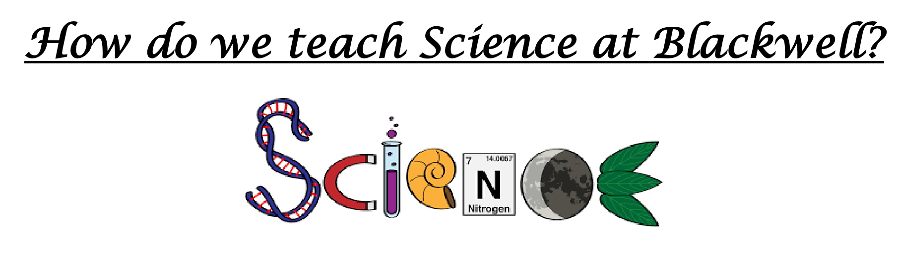
- Science as a learning driver and where not it is taught discretely.
- Cross curricular links
- Use of pre and post learning task to assess learning
- Opportunities for children to transfer and link previous knowledge to their learning.
- Assessment tracking termly and regular checks on pupils understanding of key vocabulary
- Outdoor learning whenever possible
- Visits / visitors and experiences to link to learning.
